Group Diary

Meeting Minutes #1

Date: 27/3/2015

Time:

Agenda

* Meeting with new advisor for new project

Minutes

* Today we met up with our new advisor to talk about the possible projects that we can work on. The previous project seems too difficult due to the lack of expertise in the game development field. We listed a few possible projects that we are interested in and capable of doing from a list of projects. Two projects that stood out was Body Systems and Car systems, both bring distributed systems project.
* We decided to take on the Car Systems project.

Action Item

* Thinking of possible ideas/ways for implementation of software

Meeting Minutes #2

Date: 30/3/2015

Agenda

* Discussion on the project, Car Systems

Minutes

* We discussed how the system would look in terms of its interface. Buttons which surrounds a car represents different parts of the cars, and detailed description is given for each parts.
* For later parts of the project, as we simulate the processes in a car, for example refuelling the car, different parts of the car which are required for the process are shown and a simple animation of sort will show how the process is done.
* The implementation of a quiz to test the users on his knowledge on cars could be implemented in the system.
* Other than learning the processes in a car, the software also aims to teach the users things such as what each dashboard symbol represents and much more.

Agenda

* Learning of Visual C++
* Requirements
* Presentation

Meeting Minutes #3

Date: 2/4/2015

Agenda

* Review on presentation and prototype

Minutes

* Dyalan and Elle showed the prototype they have been working on to Luke. Reconfirmation on what program should be used was also directed towards Luke. Visual C++ and Qt were both being considered for the development of the project. Much more learning would be required for using Qt compared to Visual C++. We decided to stick with Visual C++ for now.
* Kapil then showed Luke the presentation that he has been working on and modified from the previous project. Discussions were brought up on things that might require changing. This allow for further understanding of the project in hand for all of us as a group and how we will soon approach it.

Action Item

* Continue development of prototype
* Presentation and requirements

Meeting Minutes #4

Date: 24/4/2015

Agenda

* Meeting up with advisor to discuss what to do from this point onwards.

Minutes

* Elle and Dyalan clarified on the resolution to be used for the program. Pictures to be used for the interior of the car could possibly be found on the manufacturer’s website.
* For the quiz, a different car model might be used to prevent users from memorizing parts of the car to answer the quiz.
* The software should have multiregional support, different components of the car is named differently in different countries (e.g boot and trunk). There may also be a difference in which side the driver drives on and should be included.
* We then discussed the deliverables needed for the end of the semester, which includes design documents such as class diagrams and use cases, data dictionary, a short script on how the threading for the simulation would be implemented, test methodology (black box and white box testing), assumptions that can be made, user acceptance testing, convention naming variables(?), design choices, load testing.
* If possible we would try to complete the first phase of the software and also a framework for the quiz.
* We then discussed on how implementation of the infographic section can be done, highlighting different components of the car when a name is clicked on. This process might involve photoshopping a lot of photos. Simple but tedious and time consuming.
* Allocation of work, Wee will work on use case diagram, Elle and Dyalan on the user manual, Kapil on documentation.

Action Item

* Use case diagram and description (Wee)
* User manual (Elle and Dyalan)
* Documentation (Kapil)

Meeting Minutes #5 Date: 1/5/2015

Agenda

* Meeting up with client to for a brainstorming session

Minutes

* We first discuss about the quiz section of the software, addition of an instruction page that will be displayed to the user upon clicking “Quiz” from the main menu which allows the user to be able to prepare before actually taking the quiz; instead of a submit button to confirm submission of answers by the user, we can use next buttons (clicked using mouse) to go the next question and in addition to that we will have boxes at the bottom part of the quiz which will represent number of the question that can be clicked to jump to different questions (different colours to represent different situations, different colour for questions that are not answered, different colour for questions that are answered and different colour for the question the user is currently in); upon submission, the program will have to check if the user has answered all the questions; if the user decides to leave mid-way through a quiz, an abort button will be available for the user to click and it will bring the user back to the main menu; the button to exit the program on the top right should be hidden so that the user will not be able to exit that way (this is to prevent any dynamic memory initialized in the system from being lost); for the review of the quiz, the user will be able to view all the questions that have been answered, for wrongly answered questions, the box that represents the question that is answered wrongly will be coloured differently so that the user will be available to click and review the questions that he/she has answered incorrectly by clicking on it; we should try to make the system register keyboard inputs by the user so that he can navigate through the questions and also at the same time answer questions; we will also have 10 drag and drop questions in addition to the 10 MCQ; the order of the answer for a question will change; we will also have parameterized questions (context is the same, the meaning of the question is the same but expressed in different words, the answer for the question will also be the same);
* The screen size should not be full screen due to the different screen sizes people will have so for now we have decided that the screen size would be set to 1024 \* 768.
* For the infographics part, to register a mouse click of the user on a particular component of the car can either be done by placing a square box on that particular component, or checking the mouse click coordinates against the placement of the component on the screen (hard to express it in words) (quiz interface for drag and drop will use the similar interface); for the infographics part, there will be buttons up, down, left and right, starting from the default view, clicking up will zoom in one layer and by clicking left and right you change views.
* For the videos part, we can use an embedded player or allow the user to open up their local media player instead of going through via Youtube as it will require internet connection. For the embedded player, we will try to darken down the back and put the video layout on top.

Action item

* Use case description (Wee)
* Sequence diagram and communication diagram (Dyalan)
* User manual (Elle)
* Documentation (Kapil)

Meeting Minutes #6

Date: 8/5/2015

Agenda

* Another brainstorming session

Minutes

* Kapil confirmed the documentation needed for the final submission of the first semester and talked briefly on the website. Things to finish up include class diagram, data dictionary and state diagrams (There is actually more than this).
* We started talking a bit on the sequence and communication diagram for the fuel simulation. We discussed on how there would be a normal simulation of the car upon clicking on any simulation.
* As we discussed, we come to an agreement that there would be a persistent UI for the simulation part, where a dashboard would be placed permanently on screen, and any change in data would change accordingly on the dashboard. Things that will remain persistent on the screen would include the dashboard, the start and stop engine button, the speed bar and also the incline (terrain, increase angle [probably needs better wording]) bar.
* We also discussed on the simulation of the fuel system. For example, if the user wishes to fill petrol into his car, he/she would need to reduce the speed of the car and then turning off the engine (probably the off button) before being able to fill his/her car.
* The speed of the car will increase gradually when being displayed on the dashboard (instead from 0 – 40 instantly)
* A normal flow of the system when being used by the user started from the menu, clicks the simulation, the system shows the persistent interfaces (dashboard, speed bar, incline bar, start and stop engine), user starts the engine, speed increases, dashboard updates accordingly. User now wants to try how the increased incline would affect the speed of the car and the rate of fuel consumption, user would be able to see the change in speed on the dashboard but to view the rate of fuel consumption, user clicks on “Fuel system” and would be able to see in details the changes that occur in the fuel system.

Action Item

* Use case (Wee)
* Sequnce and comm diagram (dyalan)
* User manual (Elle)
* Documentation (Kapil)

Meeting Minutes #7

Date: 15/5/2015

Agenda

* Brainstorming with client again

Minutes

* We talked briefly about the project computers that we have got from the university. Most of the applications that we need are not available and we will have to install all the applications ourselves.
* We then update each other on the deliverables for the final week of the semester. We talked briefly on the dashboard for the simulation of the different processes in the car. We talked about the website. Wee will continue working on the use case, Elle will work on the mockup for the system, Dyalan will work on the sequence diagram and Kapil will work on the website. Things that will need to be worked on after we finish our individual parts is the class diagrams and the state diagrams.
* We got a tablet from Luke today which will be used by Elle for the editing of images for the system
* We also discussed briefly on things that we might want to install on the project computers, Visual Studio is one of them

Action items

* Use case description (Wee)
* Kapil (Website)
* Elle (System mock up)
* Dyalan (Sequence diagram)

Meeting Minutes #8

Date: 29/5/2015

Agenda

* Updating on progress

Minutes

* We talked about the performance of the program that Elle and Dyalan has worked on so far. There seems to be a slight delay when trying to load all the buttons under the quiz section Kapil suggested that multithreading might be able to help us improve the performance of the software. We also would want to reduce the cluster of buttons if possible for the program.
* Development on the threading part for the simulation shall be worked on command line for now. This is because it will make it easier for development among different platforms (Mac and Windows). At later iterations, we will then merge it into the interface of the program.
* We also talked about the default values for the simulation as the car starts up. The speed should remain at 0, temperature set at the “air temperature” (around 20 to 30) and fuel would be set at 80%. There would be slight changes needed to be made for the interface to display the metrics used for the measurement of fuel and the speed. For the incline section below the persistent dashboard, it should also be made bigger so that it would be possible to accommodate 4 digit values.
* For the class diagram, we realized that we can use multiple abstract classes. We then use inheritance from the abstract classes to define different components in the system. We can generalise components to make it look less clustered. The pump should have a pressure variable.
* There should also be a maximum number of incline and maximum number for altitude.

Action items

* State diagrams
* Class diagrams
* Compilation will be done by Kapil

Meeting minutes #9

Week 1 of semester break

Agenda

* Just updating on what was accomplished on week 1

Minutes

* We manage to sort the infographics into different hierarchies. Wee has been writing the code that will allow reading it in from the text file and putting them as a vector of classes (Inside folder codes). Wee will continue working on making a text file editor, to allow easy changing of the text file in the case of changing component description or names.
* Elle has started working on photoshopping the images and will continue doing so
* Dyalan is working on the visual side of things, the interface. Wee will be working with dyalan in order to integrate the infographics system.
* Kapil will be working on the simulation side of things.
* Below are a few screenshots on how we decided to go about implementation of the infographics system

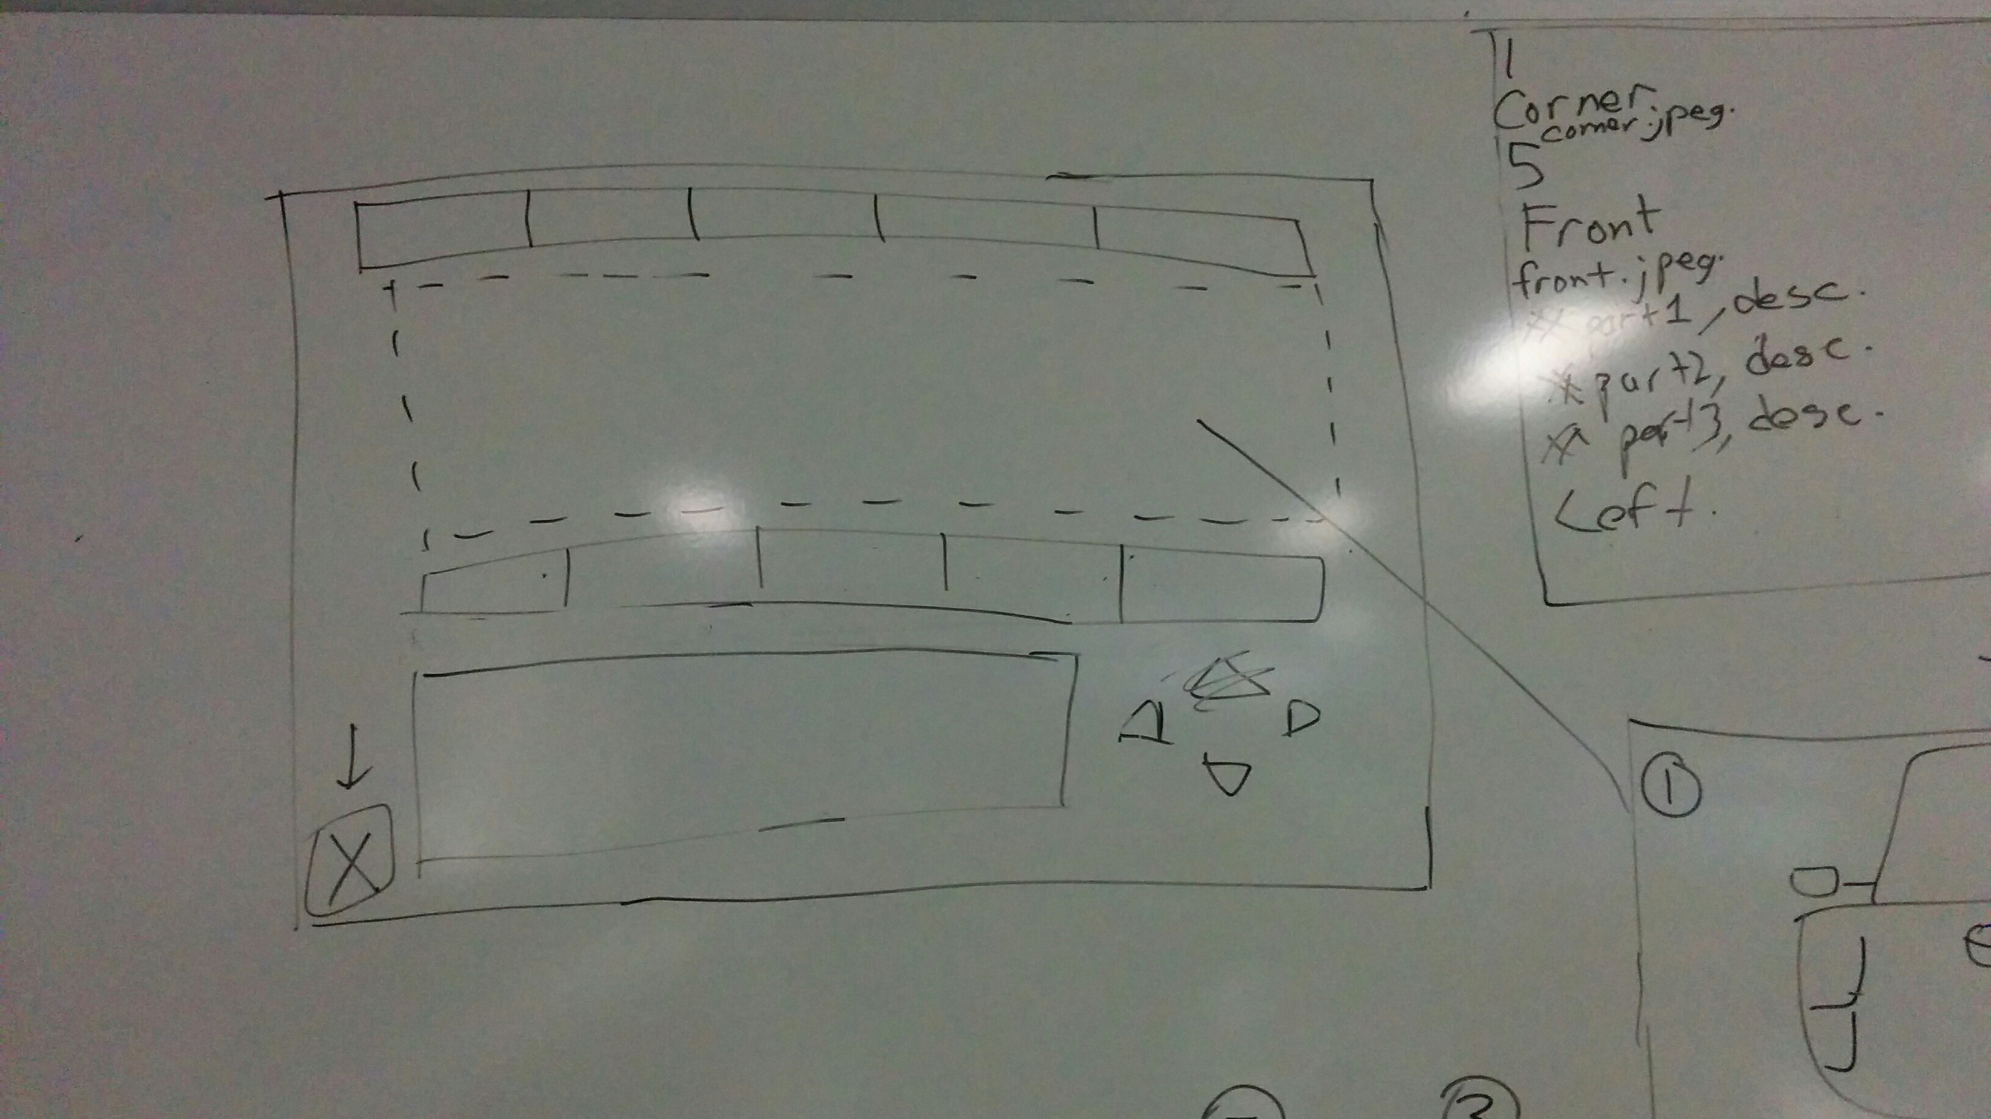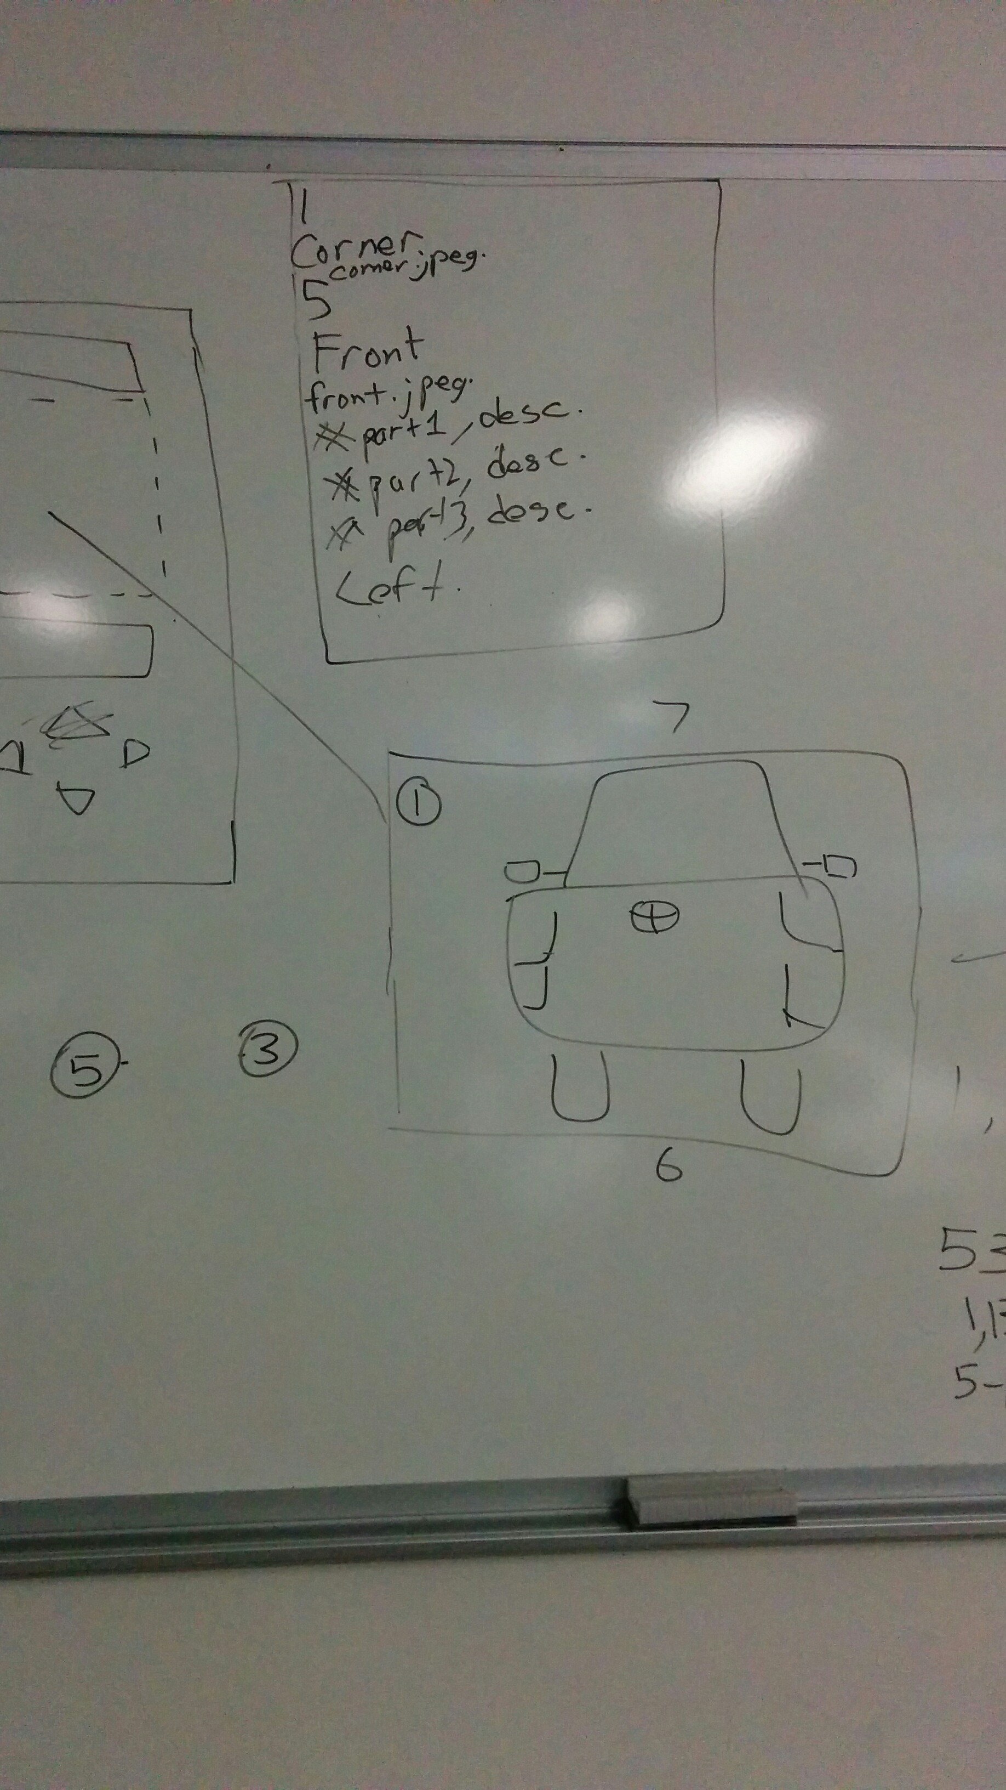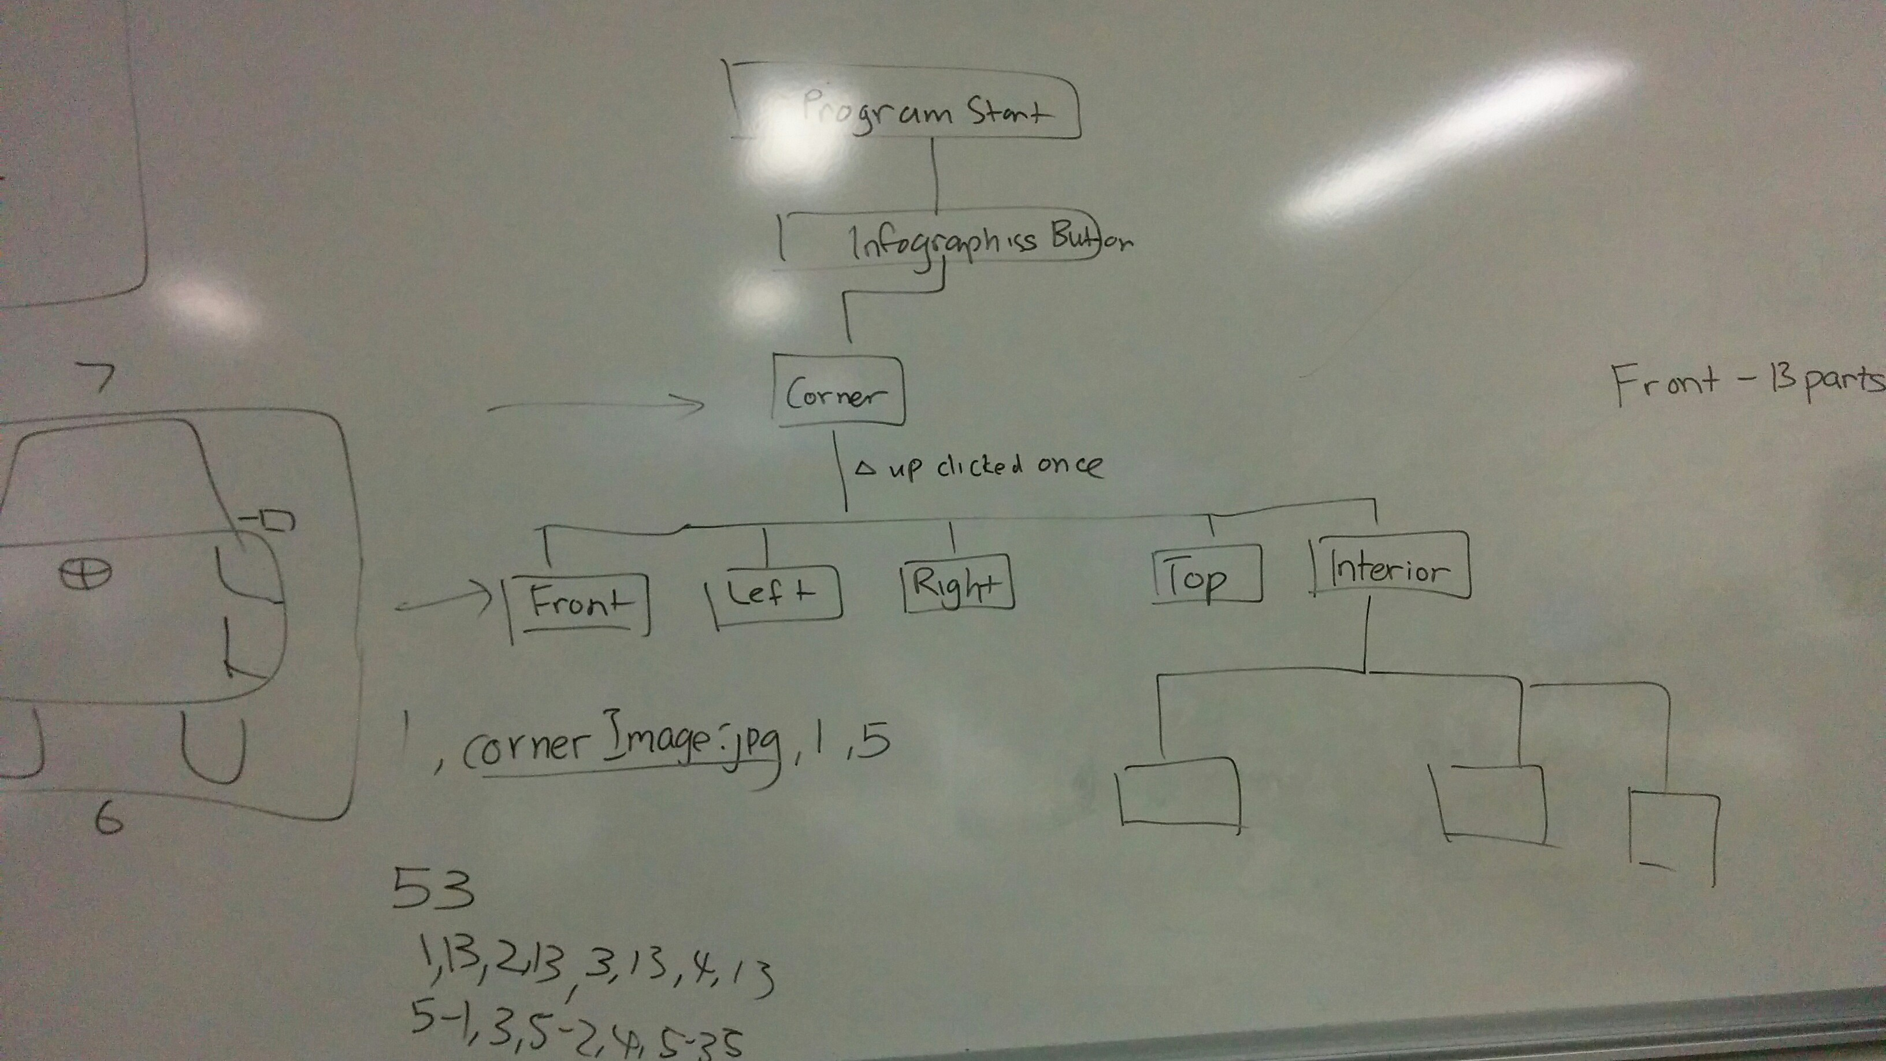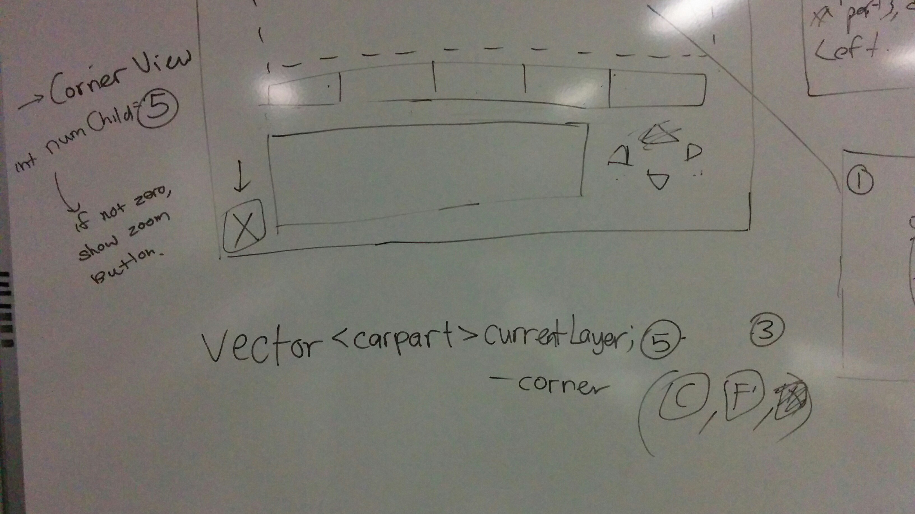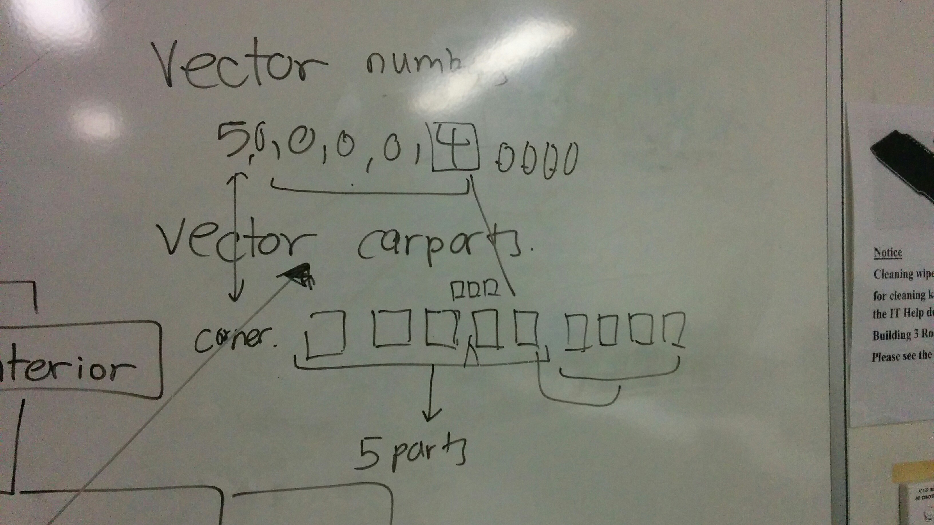

Action item

* To continue development of the system

Meeting minutes #10

Date: 30/7/2015

Agenda

* First meeting of the semester

Minutes

* By the end of the holiday, most of the photos to be used for the infographics were already completed. The code also to read in the file to be used for the infographics has also been roughly completed.
* In the meeting today we showed Luke what we have done so far for the infographics, there were a few bugs here and there that required fixing, such as when zooming out the program should be clearing the description box and we should also grey out the button which will tell the user that he/she is not able to zoom in. Testing should also be done for the code used for the infographics. The text file for the infographics should be converted into XML form, but with the presence of the text editor, there is no need to convert it into XML form.
* We also discussed that the simulation for the engine and the fuel tank is to be done in the upcoming weeks

Action Item

* To fix up the bugs in the infographics
* Start working on the simulation codes

Meeting minutes #11

Date: 6/8/2015

Agenda

* Meeting up with Luke again

Minutes

* Today we showed Luke what Kapil has planned on trying to take on the simulation part. We should take into consideration many things when working on the simulation such as when simulating the fuel system, we want to be able to also simulate what would go wrong in the car when the wrong type of fuel is injected into the car. We would have a simulation manager class where it would detect changes in different parts of the system and tells different components on the current situation. We will also be working on console first before integrating it into our Visual Studio project. We should also be using some external libraries to draw in the program, for example, to simulate the fuel level we will use the external library to draw how much fuel is left. Libraries to be considered are OpenGL and SFML.
* Today we also showed off the project website to Luke and gain feedback on what could be improved for the website
* We then discussed about the demo for the project which is in the upcoming week. We should prepare a list of requirements and mark off which requirement has been accomplished. We should tell the assessors what has been done and what we are going to do in the upcoming weeks.

Action Item

* Learn up external libraries that can be used for drawing in the program
* Continue working on the simulation code

Meeting Minutes #12

Date: 20/8/2015

Minutes

* Last week was the demo for the project. We showed the project to the assessors and gain valuable feedback. Things to work on include improving some parts in the infographics (Adding safety features). We also continue working on the simulation part of the system.
* We showed what we have done so far for the simulation. We showed SFML code and how we had to thread the window on its own as windows form does not work too well with SFML. For the simulation part we also discussed on how audio is to be played when running different simulation (And also playing music for the radio).
* There is not much for the documentation to be working on for now.

Action Item

* Continue working on simulation
* Continue learning SFML

Meeting Minutes #13

Date: 27/8/2015

Minutes

* A part of the simulation has finally been completed. Kapil says we should be able to dish out 1 subsystem per week.
* We also decided that instead of working on SFML and windows form together for the simulation part, we should just use a SFML window entirely instead. Elle has found out that it is difficult to integrate SFML into Windows form, and by using SFML for the simulation instead, it should be easier to work with without having to worry about Windows forms.

Action Item

* Continue working on simulation
* Integrate simulation in SFML